High Voltage Techniques Miniproject
2013
Description of 60 kV voltage transformer and assessment of the insulation quality
Cordinator: Claus Leth Bak
Anubhav Sabharwal, David Martinez Perez, Mario Zaja, Matei Oprea, Riccardo Carollo, Volodymyr Myagkov,
Group 3

Contents
1 Description of voltage transformer 3
2 Transfer ratio 6
3 Lightning overvoltage test 8
3.1 Lightning overvoltage 8
3.2 Impulse voltage generator circuit 9
3.3 Test setup and measurements 10
3.4 Results and discussion 11
4 Dielectric loss angle 12
5 Partial Discharge 16
5.1 The basic PD test circuit 17
5.2 PD measuring systems within the PD test circuit 17
5.3 PD measurements 19
6 Dielectric spectroscopy 21
7 Conclusion 26
8 Bibliography 27

Description of voltage transformer
EMF Inductive voltage transformers is electrical devices used for transmission and distribution of alternating current or voltage over long distances from one electric circuit to another by using electromagnetic induction[1].
The main structure of an inductive voltage transformer consists of two circuits such as primary circuit and secondary circuit. Those circuits electrically insulated with layer insulation of special paper and have no electrical connection to each other. Primary circuit consist of the primary windings and secondary circuit has secondary measurement winding and tertiary winding for ground fault protection.[2]Those windings are made of double enameled wire with layer insulation and wound onto the same iron core.
As transformers act by mean of electromagnetic induction, the change in the current in primary circuit will produce a change in voltage in the secondary circuit. Inductive voltage transformer EMF designed in such way to withstand continuous overvoltage because of the low core flux density. The rated primary and secondary voltage determine the performance of the transformer.
AAB Switchgear |  | Nr 8350834
High voltage transformer |  | Type EMF 72
Insulation level 140-350kV |  | Highest Voltage for equipment 72.5kV 50Hz
Standard IEC 186 |  | Voltage factor (Vf) 1.9/8hrs
Total mass 190kg |  | Year 1998
A-N | 1a-1n | 2a-2n | da-dn
60000V/√3 | 110/√3 | 110/√3 | 110/√3 | V
Load | 1-15 | 1-65 | 75 | VA
Class | 0.2 | 0.2 | 3P
Table 1 Rated data ABB’s inductive voltage transformer of a 60kV (ABB EMF 72).
For the laboratory test measurements is used ABB’s inductive voltage transformer of a 60kV (ABB EMF 72) (Table 1).
Transcript of transformer rated data from table 1:
AAB Company produces high Voltage Transformer Type EMF 72 in 1998 year with serial number 8350834. It has insulation level from 140kV up to 350kV and highest voltage for equipment is 72.5kV with rated frequency of 50Hz.As it operate with low flux density at rated voltage, IEC specifies the voltage factor 1.9 of the rated voltage for the systems, which not solidly earthed during the earth faults with duration up to 8 hours.[3] Rated voltage on primary windings is60000/√3V and 110/√3V on the secondary windings accordingly. Last part is describes the loading of the secondary windings respectively.
Design of EMF Inductive voltage transformer is shown in Figure 1.
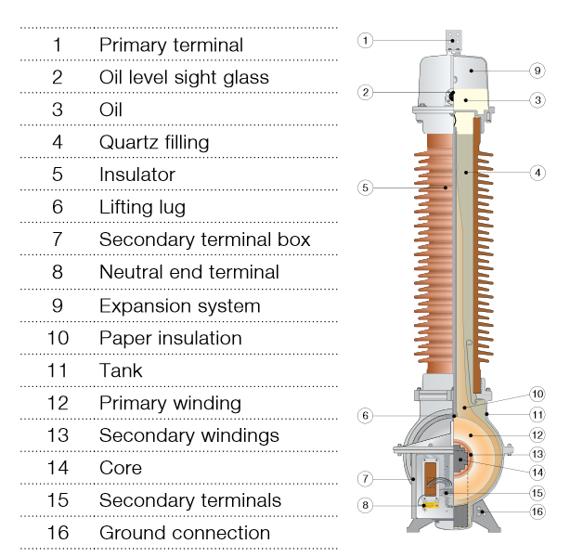
Figure 1 Inductive voltage transformer [2]
The widely use of dielectric liquids and materials for high voltage insulations is due to their greater electrical breakdown strength and thermal conductivity. The main disadvantage of dielectric liquids in case of the failure can cause damage to not only high voltage equipment but also pollution of the environment. In order to minimize risk of pollution, in ABB’s inductive voltage transformer is used quartz filling which reduce the quantity of oil. Moreover, it provides a mechanical support for the parts such as core and primary windings.
In order to carry out very large changes of pressure in the no-load and loaded conditions, expansion system filled with nitrogen that act as a cushion for expansion of the oil. The main advantage of nitrogen use is that the oil and insulations are maintained in dry conditions.
Porcelain is used for the insulation because it has very good dielectric strength. Primary and secondary windings designed from double enameled wire with insulation of special paper. Transformer core and windings placed in aluminum tank, which has high degree of resistance to corrosion[2].
In order to have long service life an transformer and its parts must be capable of withstanding very high voltage stresses such as lightning and switching overvoltage and be capable to operate in all climatic conditions.
There are described several methods in how to test transformer and insulation in order to define its conditions.
Tests and measurements: measure transfer ratio full range, power frequency and lightning overvoltage, dielectric loss angle, partial discharge measurement and dielectric spectroscopy.

Transfer ratio
Transfer ratio of any voltage transformer is defined as:
 | $$n=\frac{V_{1}}{V_{2}}$$ | (1)
V₁ represents the higher voltage level, usually primary, while V₂ lower voltage level, usually secondary. With respect to turns ratio, the former equation can be written as:
 | $$V_{1}=\frac{N_{1}}{N_{2}}V_{2}+∆V$$ | (2)
N₁ and N₂ represent number of turns of primary and secondary winding respectively, while ∆V is a voltage drop with respect to primary. Voltage drop depends on transformer parameters as well as load attached. Inductive and purely resistive load increase the voltage drop, while a capacitive load can sometimes even reduce it. This is because transformers are inductive, so a capacitive load compensates for the inductance causing the voltage drop in the transformer.
For an ideal transformer, voltage drop is zero, so the transfer ratio is the same as turn ratio.
 | $$\frac{V_{1}}{V_{2}}=\frac{N_{1}}{N_{2}}$$ | (3)
Ideal transformer has no losses, so the output power is the same as input.
 | $$V_{1}I_{1}=V_{2}I_{2}$$ | (4)
Therefore, current transfer ratio of a voltage transformer is reciprocal to the voltage transfer ratio.
 | $$\frac{I_{2} }{I_{1}}=\frac{V_{1}}{V_{2}}=n$$ | (5)

Voltage transfer ratio of a given transformer was measured at no load condition. The results are given in Table 2.

V₁ [kV] | V₂ [V] | V₁/V₂
2.5 | 4.54 | 550.66
3.95 | 7.26 | 544.08
7.96 | 14.75 | 539.66
16.01 | 29.55 | 541.79
31.9 | 57.97 | 550.28
40.12 | 73.1 | 548.84
Table 2 Voltage transfer ratio measurements
Theoretical transfer ratio of this transformer is:
 | $$n=\frac{V_{1}}{V_{2}}=\frac{60000/\sqrt{3}}{110/\sqrt{3}}=545.45$$ | (6)
The measurements are valid since they were taken with no load, meaning that only core losses are present. Losses at rated load are higher, making secondary voltage lower, therefore increasing the transfer ratio. As it can be seen from the Figure 2, line representing the ideal secondary voltage level has a bit bigger slope than the measured one.

Figure 2 Measured and ideal secondary versus primary voltage
Even though transfer ratio of a given transformer is not a constant, maximum transfer ratio error within the nominal operating range is less than 1%, making it precise enough for regular usage.

Lightning overvoltage test

Lightning overvoltage
Disturbances of electric power transmission and distribution systems are frequently caused by transient voltages whose amplitudes may greatly exceed the peak values of the normal a.c. operating voltage.
One kind of disturbance is caused by lightning overvoltages. Those are originated by lightning strokes hitting the phase wires of overhead lines or the busbars of outdoor substations. The amplitudes are very high compared to the rated voltage of the line and every stroke may inject lightning currents up to even more than 100 kA into the transmission line; each stroke is then followed by travelling waves, whose amplitude is often limited by the maximum insulation strength of the overhead line. Too high voltage levels are immediately chopped by the breakdown of the insulation and therefore travelling waves with steep wave fronts and even steeper wave tails may stress severely the insulation of the power equipments[4].
Even though the form of the lightening wave varies depending on the transmission system's insulation, lightening protection systems, surge arresters and losses, some similarities can be observed and lead to a common definition for impulse voltages, as a unidirectional voltage which rises more or less rapidly to a peak value and then decays relatively slowly to zero.
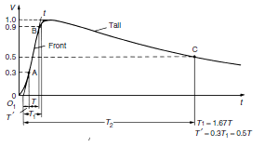
The first figure shows the shape of for a full lightning impulse voltage, while the others represent the same voltage chopped at the tail or at the front respectively. 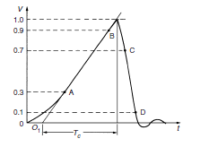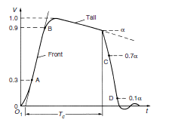
Figure 3 Shape of for a full lightning impulse voltage
Figure 4 Shape of for a full lightning impulse voltage chopped at the front respectively tail
T1 represents the front time while Tc is the time to chopping.

Impulse voltage generator circuit
The rapid increase and slow decay can be generated by discharging circuits with two energy storages, as the waveshape may well be composed by the superposition of two exponential functions.
The circuit used for impulse generator is shown in the next figure.
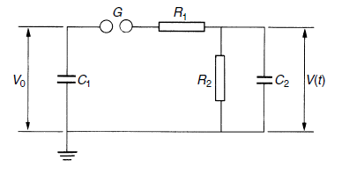
Figure 5 Impulse generator circuit
The capacitor C1 is slowly charged from a d.c. source until the spark gap G breaks down. This spark gap acts as a voltage-limiting and voltage-sensitive switch, whose time to voltage breakdown is very short in comparison to T1. The resistors R1, R2 and the capacitance C2 form the waveshaping network. R1 will primarily damp the circuit and control the front time T1. R2 will discharge the capacitors and therefore essentially control the wavetail. The capacitance C2 represents the full load, i.e. the object under test as well as all other capacitive elements which are in parallel to the test object.

Test setup and measurements
The characteristic waveshape of a lightening impulse is created by the previous single-stage generator circuit. The circuit is powered by an a.c. voltage source, which is galvanically isolated from the circuit by a transformer, which leads also to apply different voltages to the same test object without modifying the circuit. The transformer is connected to a half-wave rectifier in order to supply the single-stage generator circuit with a d.c. voltage.
A capacitor and a resistor are placed in shunt to the test object to avoid large variations of the ratio between front time and time to half-value (of the maximum value of the lightening impulse voltage) with changing test objects For this test a capacitive voltage divider is required to obtain a direct measurement from the conductor with the overvoltage itself that is being used without employing any intermediate devices that would decrease the accuracy of the test like a voltage transformer. The test object is connected directly to the voltage divider which is connected to the measurement device itself.
In the case taken into account the test object consists of an air gap, created by an electrode connected to the ground system. This electrode is separated from the conductor from a specific distance, this has the purpose of simulating the air gap between a conductor and a conductive structure connected to ground. This test measures how much voltage a system can maintain during an overvoltage until a breakdown occurs. If it does, a spark appears between the conductor and the ground. An electrical breakdown consists of (in this case) a ionization of the air and therefore an appearance of an electric arc because the strong voltage peak transforms the insulation into a conductor.
A statistic method has to be applied to analyze the breakdown probability for a given voltage, due to the random nature of those events. For this reason enough amount of tests have to performed at each test voltage to increase the amount of accuracy of the test results. Each voltage will be tested a multiple amount of times and the amount of breakdowns will be counted for each specific voltage.

Results and discussion

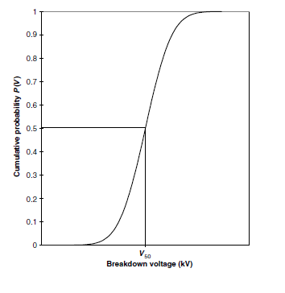
Figure 6 Discharge probability depending on the crest voltage
The behavior of the insulation is described by the discharge probability depending on the crest voltage[4]. A commonly used method is to apply the cumulative distribution function as shown in the next figure, where V50 the voltage which has the discharge probability of 50 per cent and the standard deviation of the measurement series.
The aim is to define V50 in order to describe the distribution function correlating to the test object. A table with the measurements is provided in the following.
It can be seen that at a voltage level of 54kV 1 of 5 tests led to a breakdown (P=20%) and at 55kV 1 of 2 (P=50%). However, the probability of having a breakdown with a higher voltage, 56 kV, is lower: only one out of 11 test (P=9.09%). It can be seen that a breakdown occurs also with lower voltages, like 42kV. A statistic distribution of the discharge probability can not be provided with those data.

Dielectric loss angle
When an electric field is applied in a dielectric, positive and negative charges shift leading to a polarization of this dielectric.
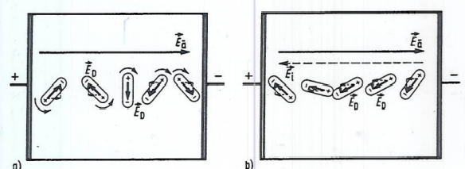
Figure 7 Polarization of the dielectric
Besides, the electrical field is not able to force the charges, leading to electric conduction. This is exactly what happens with an ideal dielectric. However, the real dielectrics will have some losses, which can be:
- Conductive losses (P₁): caused by electronic conduction.
- Polarization losses (P_{p}): deformative polarization.
- Ionisation losses (P_{i}): partial discharges.

These last can be represented in the equivalent circuit of a dielectric:
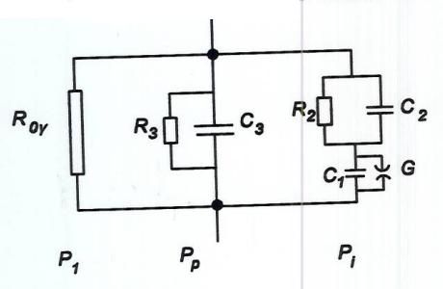
Figure 8 Equivalent circuit of a dielectric
Each loss can be measured with non destructive HV methods. The importance of these methods responds to the need of testing expensive component's insulators: there is a relation between the measured losses and some important parameters and properties concerning the dielectric (e.g. test voltage or temperature).
The method applied in this lab session is the AC dielectric loss angle (δ), in which the ratio between the total losses and the reactive power is obtained:
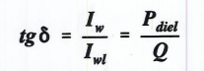(7) (8)
In order to obtain the loss angle and the capacitance, the Schering bridge method will be applied:
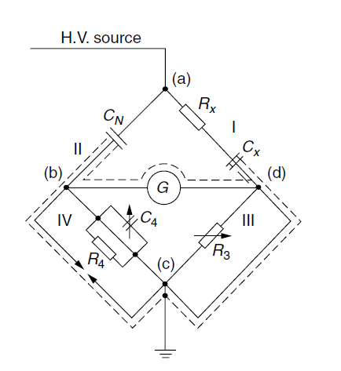
Figure 9 Schering bridge
The lab experiment measured the transformer first, connecting the primary in (a) and the secondary in (d), and a capacitor afterwards. Terminals (b) and (d), which correspond to the low voltage side, go into the measuring device TG-3MOD, which automatically adjusts R₃ and C₄ in order to obtain no current in the middle branch (i.e. V_{bd}=0). It should be remarked that the measurements should be done at 50Hz, which is the rated frequency for the transformer.
The method applied by the measuring device for calculating C_{x} and tan(δ) is now explained:
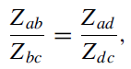(10)
where
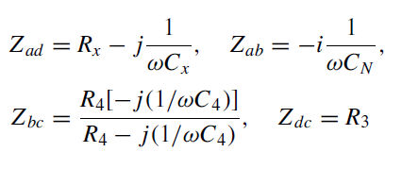(11)
From which we obtain R_{x} and C_{x}:
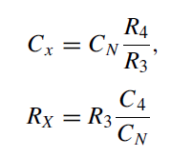(12)
Finally we can get the dissipation factor (i.e. the loss angle):
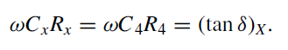(13)
The obtained results were the following:
For the transformer:

U(kV) | tan(δ) | Cx(pF) | δ(º) | 90-δ
0,00 | 0,02 | 20,02 | 1,23 | 88,77
5,00 | 0,02 | 20,02 | 1,25 | 88,75
10,00 | 0,02 | 20,03 | 1,29 | 88,71
15,00 | 0,02 | 20,04 | 1,34 | 88,66
20,00 | 0,02 | 20,05 | 1,38 | 88,62

For the capacitor:
U(kV) | tan(δ) | Cx(pF) | δ(º) | 90-δ
0,00 | 0,63 | 34,39 | 32,21 | 57,79
5,00 | 0,24 | 57,39 | 13,28 | 76,72
10,00 | 0,07 | 75,74 | 3,84 | 86,16
15,00 | 0,00 | 83,54 | 0,04 | 89,96
20,00 | -0,04 | 87,18 | -2,10 | 92,10
25,00 | -0,06 | 88,47 | -3,40 | 93,40
30,00 | -0,07 | 88,34 | -4,19 | 94,19
35,00 | -0,08 | 86,27 | -4,49 | 94,49
40,00 | -0,07 | 81,02 | -3,82 | 93,82
45,00 | -0,01 | 69,35 | -0,51 | 90,51

Whereas the capacitor presents stable values of tan(δ) and C_{x} throughout all the voltages measured, the transformer doesn't. Between 15-20kV the sign of the tangent changes, which can be explained by the change of a capacitive character to an inductive one. In this last case the reactive power becomes negative and therefore the negative sign of the tangent, considering that the losses will always be positive.
Regarding the differences between the transformer and the capacitor, this last one has less losses when voltage is different from 15kV, approximately. This is explained by the smaller tan(δ) value for all voltages except for 15kV.

Partial Discharge
It is a localized electrical discharge that only partially bridges the insulation between conductors and which may or may not occur adjacent to a conductor.
The above definition is supplemented by the following:
Partial Discharges are a consequence of local electrical stress concentrations in the insulation or on the surface of the insulation. They appear as pulses of duration of less than 1µs.
Corona: It is a form of partial discharge that occurs in gaseous media around conductors which are remote from solid or liquid insulation.
Partial discharges are the electrical discharges within the insulation system as applied in electrical apparatus, components or systems. The insulation may consist of solid, liquid or gaseous materials or combination of any of these.
The term partial discharge includes the following discharge phenomena:
- Internal discharges occurring within solid and liquid dielectrics
- Surfaces discharges appearing at boundary of insulation materials.
- Corona discharges occurring in gaseous dielectrics in the presence of inhomogeneous fields.
- Discharge channels formed by continuous impact of discharges in solid dielectrics.
Every discharge event causes a deterioration of the material by the energy impact of high energy electrons or accelerated ions. Corona discharges in air will have no influence on the life expectancy of an overhead line. Partial discharges within the thermoplastic dielectric may cause breakdown within few days.
The detection and measurements of discharges is based on the energy exchange taking place during discharge.

The exchanges can be listed as:
- Electrical pulse currents
- Dielectric losses
- E.M. Radiation
- Noise
- Increased gas pressure
- Chemical Reactions

The basic PD test circuit
Figure 10 The PD test object Ct within a PD test circuit
To evaluate the fundamental quantities related to Partial discharge pulse we simulate the test object by the simple capacitor arrangement comprising of solid or fluid dielectric materials between two electrodes and a gas filled cavity. Electrical field within the test object are simulated by partial capacitances. Electrical field lines within the cavity are represented by Cc and those starting or ending at the cavity wall form the capacitances Cb´ and Cb” within the solid or dielectric. The field lines outside the cavity are represented by Ca = Ca´+ Ca” and Cb = Cb´Cb”/ (Cb´+Cb”) where Ca>> Cc>>Cb.

PD measuring systems within the PD test circuit
To quantify the repeatedly occurring PD pulses that have quite specific distributions, a measuring system must be integrated into the test circuit. Most PD measuring systems schemes as shown in figure 2 and 3 are taken from the IEC standards.
Figure 11 Coupling device CD in series with the coupling capacitor
Figure 12 Coupling device CD in series with the test object
The difference between the two detection setups above is that in one CD is at ground potential and in series with the coupling capacitor Ck and in two CD is in series with the test object Ca.
Within these circuits the coupling device ´CD´ with its input impedance Zmi forms the input end of the measuring system. The device must be placed at the high voltage terminal side which may be necessary if the test object has one terminal earthed. Some of the essential requirements and explanations with respect to these figures as indicated by the standard are:
- The coupling capacitor shall be of low inductance design and should exhibit allow level of partial discharges at the specified test voltage.
- High voltage supply shall have low level of background noise to allow the specified partial discharge to be measured at the specified test voltage.
- Impedance may be introduced at high voltage to reduce back ground noise.

PD measurements
The tests were performed with transformer and capacitor at 15, 20, 24, 25, 45 kV.
For Transformer at 24/45 kV:
For Capacitor at 20 kV:

Dielectric spectroscopy
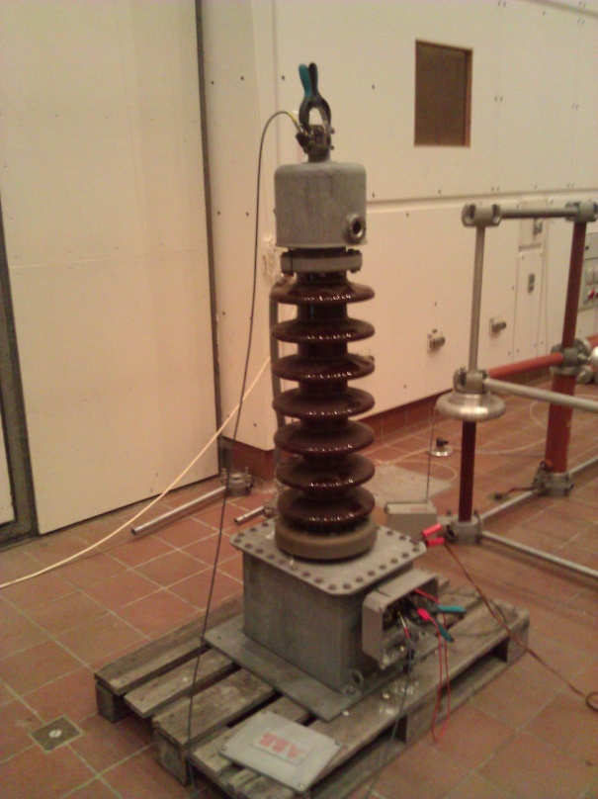
Energy is what makes the world go round nowadays. Usually electrical energy, that is, because it is smart and easy transformable in other forms of energy. In the whole distribution system, the most crucial and expensive component is the transformer. In Figure 13 can be seen an ABB EMF Voltage transformer. This device is an essential part in the big picture, because it helps achieving the level of voltage, current or power, which is needed to efficiently transport or use electrical energy.
Due to economical reasoning, the life of transformers should be maximized. They should be exploited at maximum and replaced only when they reached the end of their life. From a different point of view, an unexpected failure, due to aging or fatigue, is somehow embarrassing. Technology allows a variety of safety measures and test [5] to be implemented in order to monitor and prolong the life of these transformers. These tests are non destructive and offer sufficient information for a detailed analysis on the state of the transformer.
Figure 13 ABB EMF Voltage Transformer wired for dielectric spectroscopy test in the High Voltage Laboratory
Dielectric spectroscopy is one of the tests that can be made in order to assess the health of the insulation, the moisture level and the coils geometry in the transformer. This approach applies a frequency sweep over a wide range, usually from 1000 Hz to 0.0001 Hz, to get three characteristics. First is the insulation paper or pressboard (cellulose) response, the second is the oil insulation response and the interfacial polarization effect. The dielectric response is influenced by the moisture, temperature, insulation geometry, oil conductivity and aging [5]. In the following Figure you can observe which dielectric component influences which part of the curve. Figure 15 represents the differences between curves of different aged transformers.
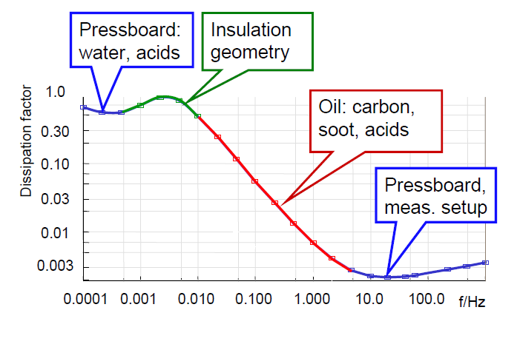
Figure 14 Dissipation factor of pressboard and oil together with the interfacial polarization effect [5]

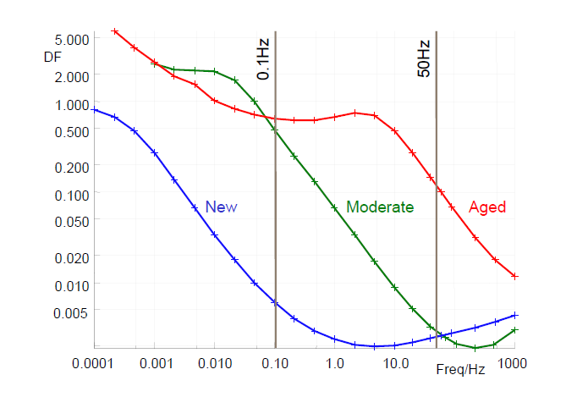
Figure 15 Dissipation factor of three transformers in different aging conditions [5]
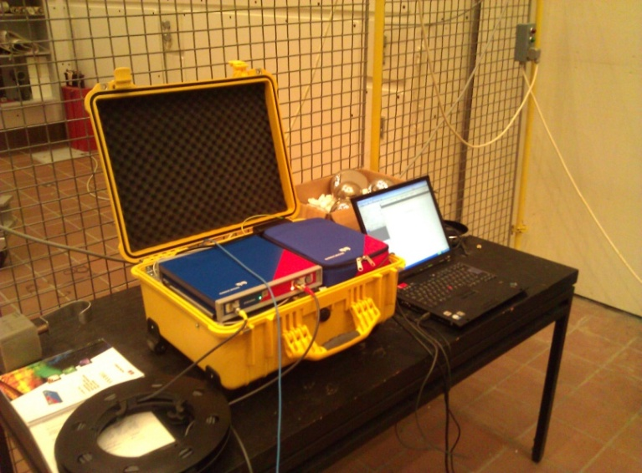
In the experimental setup has been used a voltage transformer ABB EMF. The measurement instrument used is a DIRANA, as can be seen in Figure 16, produced by OMNICRON electronics[6]. The connection to the transformer is the same as in a traditional 50 Hz transformer power factor test, the difference being that this test is performed at a low voltage. The peak is around 200 V. In Figure 17 it can be observed the response of the transformer to this test.
Figure 16 DIRANA test instrument used in for the Dielectric Spectroscopy test, in the High Voltage Laboratory
Figure 17 Response values for the Dielectric Spectroscopy test of the ABB EMF Voltage Transformer
DIRANA also comes with software that runs on the computer. This application provides a variety of predefined tests and appreciations that can quickly analyze the acquired data. The advanced assessment test is one of them. This test gives information on the moisture and conductivity of the transformer. Moisture is highly undesired because it produces dangerous effects in the transformer[6]. These effects are paper degradation and insulation aging, reduced dielectric strength of both oil and paper and lower bubbling onset temperature, which provides partial discharge inception. Result of the test can be observed in Figure 18.
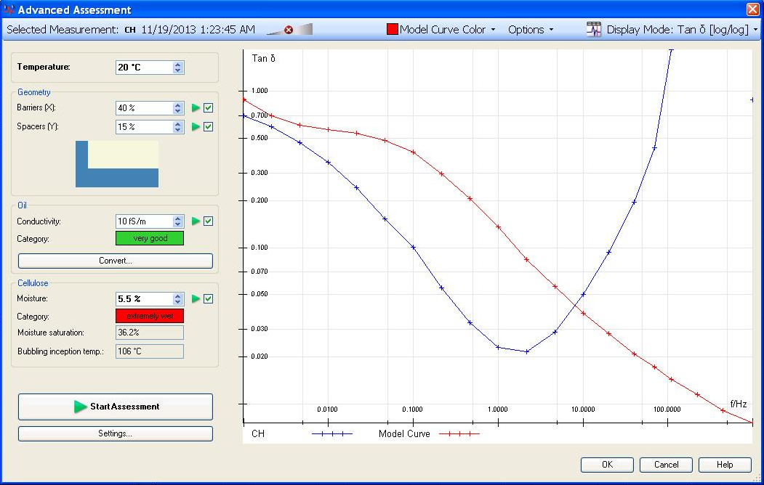
Figure 18 Advanced Assessment test made with DIRANA software for the ABB EMF voltage transformer
In practice this kind of tools are very useful because they can provide advanced methods of analyzing the state of the transformer. The results are provided fast and they are reliable, as long as the test is made for a paper or pressboard insulated transformer. Unfortunately this is not the case of the ABB EMF voltage transformer. The results show that the conductivity is very good, but the humidity level is very high. Usually humidity over 3% is a very bad result, so a 5.5% level is unacceptable. But the results are not relevant in the setup used for this test, because the insulation of this particular voltage transformer is made from oil, paper and quartz sand. So the frequency response of the ABB EMF cannot be accurately analyzed by the provided tools. Also for a real appreciation the transformer should be tested regularly, starting from the moment of its use and through the period of exploitation.
Concluding this section of the report, it must be stated that all transformers should be maintained in such a way, that their life expectancy is maximized. The non destructive insulation tests, like the dialectic spectroscopy, can be a good tool for accessing the information needed to appreciate the state of the transformer. At least but not the last, when applying an analyzing tool, the test subject must be contained or included in the specifications of that particular test, otherwise the results may be inconclusive.

Conclusion
The aim of the report was to implement different methods and tests in order to be able to examine transformer and its parts for the possible weaknesses in its operating conditions. By the commissioning, the high voltage equipment there are used basic techniques of measurement according to relevant national and international standards.
The transfer ratio measurements done for the tested transformer and data collected from the measurements shows that the transfer ratio of a given transformer is not a constant, maximum transfer ratio error within the nominal operating range is less than 1%, making it precise enough for regular usage.
The laboratory test setup was made to take measurements of lightning impulse voltage test for HV equipment. Gathered data from the measurements was analyzed.
By implementation of the high voltage Schering bridge method the capacitance and loss angle “loss tangent” was measured and measurements data is analyzed.
Capacitor presents constant values for tan (δ) and Cx and the transformer does not.
Between 15-20kV the sign of the tan (δ) for the transformer has changed.
For most part of the voltages measured, the capacitor has smaller tan (δ) values than the transformer.
The test of the insulation was done by use of the most successful detection method such as Partial discharge. For transformer at 45 kV it is not clear where the discharge actually takes place and whereas for the home made capacitor at 20 kV most of the discharge takes place between 90 to 180 degrees.
Dielectric spectroscopy test made in order to assess the health of the insulation, the moisture level and the coils geometry in the transformer.

Bibliography
[1] “Transformer definition of Transformer in the Free Online Encyclopedia.” [Online]. Available: http://encyclopedia2.thefreedictionary.com/Transformer.
[2] “Oil insulated Outdoor Instrument Transformers Buyer ’ s Guide Table of content.”
[3] “Instrument Transformers Application Guide.”
[4] High Voltage Engineering. .
[5] M. Koch, M. Krueger, and M. Puetter, “Advanced Insulation Diagnostic by Dielectric Spectroscopy By.”
[6] D. Power, “Assessing the Health of Your Transformer,” no. December, 2012.

